**1.Introduction**

**\*Background:**

The objective of the project is to create one database called Inventory Management in this we have created tables related to Products .Use this Database we can easily get the details of each product and related data using Sql querys.This helps everyone who are need to know thw details of every single product indetail with easy way using SQL querys.

Objectives:

1.Evreyone can access and retrive the data easily.

2.Only admin can changes the databases.

3.We can select,insert,update,modify,delete,drop,join the data.

**2.SOFTWARE SPECIFICATION** :

\***Language** : MySQL.

*  **Software** : Mysql work bench software.

**MySQl:**

**1.**[**Data**](https://www.linkedin.com/feed/hashtag/?keywords=data&highlightedUpdateUrns=urn%3Ali%3Aactivity%3A7230288537009487872)**-Raw fact  
2.**[**Database**](https://www.linkedin.com/feed/hashtag/?keywords=database&highlightedUpdateUrns=urn%3Ali%3Aactivity%3A7230288537009487872)**-Structered file we can retreive,access,modify,delete,changes  
3.**[**DBMS**](https://www.linkedin.com/feed/hashtag/?keywords=dbms&highlightedUpdateUrns=urn%3Ali%3Aactivity%3A7230288537009487872)**-Software  
4.**[**SQLcommands**](https://www.linkedin.com/feed/hashtag/?keywords=sqlcommands&highlightedUpdateUrns=urn%3Ali%3Aactivity%3A7230288537009487872)**:**[**DDL**](https://www.linkedin.com/feed/hashtag/?keywords=ddl&highlightedUpdateUrns=urn%3Ali%3Aactivity%3A7230288537009487872) **(Data Definition Language): Used to define and manage database structures.  
CREATE, ALTER, DROP, TRUNCATE, RENAME**[**DML**](https://www.linkedin.com/feed/hashtag/?keywords=dml&highlightedUpdateUrns=urn%3Ali%3Aactivity%3A7230288537009487872) **(Data Manipulation Language): Used to manipulate data in tables.  
INSERT, UPDATE, DELETE**[**DQL**](https://www.linkedin.com/feed/hashtag/?keywords=dql&highlightedUpdateUrns=urn%3Ali%3Aactivity%3A7230288537009487872) **(Data Query Language): Used to query data from the database.  
SELECT**[**DCL**](https://www.linkedin.com/feed/hashtag/?keywords=dcl&highlightedUpdateUrns=urn%3Ali%3Aactivity%3A7230288537009487872) **(Data Control Language): Used to control access to data.  
GRANT, REVOKE**[**TCL**](https://www.linkedin.com/feed/hashtag/?keywords=tcl&highlightedUpdateUrns=urn%3Ali%3Aactivity%3A7230288537009487872) **(Transaction Control Language): Used to manage transactions.  
COMMIT, ROLLBACK, SAVEPOINT, RELEASE SAVEPOINT  
  
5.Constraints -not null, primary key,foreign key,unique,check,default  
6.Where clause**[**7.group**](http://7.group/) **by,order by ,having  
8.aggregate functions  
9.string functions and date functions and numeric functions  
10.joins ]  
11.views  
12.CTEs**

**Project:**

**create database InventoryManagement;**

**use** InventoryManagement;(To use the created data base we have to use “use” key word as use data base name)

**Products Table**

For creating a table we have to use “create” key word

Syntax: create table table_name(column name types constrains(if any needed)

create table Products (product_id INT PRIMARY KEY AUTO_INCREMENT,

product_name VARCHAR(100) NOT NULL,

category_id INT NOT NULL,

price DECIMAL(10, 2) NOT NULL,

stock_quantity INT NOT NULL,

reorder_level INT NOT NULL);

For inserting values into table we have to use “insert” key word

Syntax: insert into table_name vales(data)

insert into products values(1,'Laptop', 1, 1200.00, 50, 10),

(2,'Smartphone', 1, 800.00, 100, 20),

(3,'Tablet', 1, 600.00, 75, 15),

(4,'Smartwatch', 1, 250.00, 150, 30),

(5,'Headphones', 1, 150.00, 200, 50),

(6,'Monitor', 1, 400.00, 60, 12),

(7,'Gaming Console', 1, 400.00, 35, 7),

(8,'Graphics Card', 1, 700.00, 25, 5),

(9,'Motherboard', 1, 250.00, 55, 11),

(10,'Power Supply Unit', 1, 150.00, 70, 14),

(11,'Keyboard', 2, 50.00, 500, 100),

(12,'Mouse', 2, 30.00, 600, 120),

(13,'Printer', 2, 300.00, 40, 8),

(14,'Webcam', 2, 80.00, 100, 20),

(15,'External Hard Drive', 2, 100.00, 80, 20),

(16,'USB Flash Drive', 2, 20.00, 300, 60),

(17,'Cooling Fan', 2, 25.00, 150, 30),

(18,'Portable Speaker', 2, 80.00, 100, 20),

(19,'Speakers', 2, 120.00, 80, 16),

(20,'Bluetooth Dongle', 2, 15.00, 200, 40),

(21,'Router', 3, 90.00, 60, 12),

(22,'Network Switch', 3, 200.00, 40, 8),

(23,'Wireless Adapter', 3, 35.00, 90, 18),

(24,'Smart Home Hub', 4, 150.00, 45, 9),

(25,'Smart Light Bulb', 4, 20.00, 150, 30),

(26,'Smart Thermostat', 4, 200.00, 40, 8),

(27,'Smart Doorbell', 4, 180.00, 35, 7),

(28,'Security Camera', 4, 100.00, 70, 14),

(29,'Robot Vacuum', 4, 400.00, 20, 4),

(30,'VR Headset', 5, 350.00, 30, 6),

(31,'Drone', 5, 1000.00, 15, 3),

(32,'Projector', 5, 500.00, 25, 5),

(33,'Fitness Tracker', 6, 100.00, 120, 24),

(34,'E-Reader', 6, 120.00, 50, 10),

(35,'Portable Charger', 6, 40.00, 200, 40),

(36,'Smartwatch', 6, 250.00, 150, 30),

(37,'Digital Camera', 7, 600.00, 30, 6),

(38,'Action Camera', 7, 400.00, 25, 5),

(39,'Electric Scooter', 8, 700.00, 15, 3),

(40, 'Electric Bike', 8, 1200.00, 10, 2),

(41, 'Range Extender', 3, 45.00, 70, 14),

(42, 'Network Cable', 3, 10.00, 500, 100),

(43, 'Smart Plug', 4, 25.00, 200, 40),

(44, 'Smart Lock', 4, 150.00, 50, 10),

(45, 'Streaming Device', 5, 60.00, 100, 20),

(46, 'Wireless Earbuds', 6, 150.00, 200, 50),

(47, 'Tripod', 7, 70.00, 100, 20),

(48, 'Hoverboard', 8, 350.00, 20, 4),

(49, 'Office Chair', 9, 150.00, 60, 12),

(50, 'Standing Desk', 9, 400.00, 30, 6);

**DELETE FROM Products WHERE product_id = 1; (if we didn’t mention where condition the whole data will be deleted from the table)**

**drop table Products; (delete the whole table from data base)**

**select*from products; (Fetches the whole data from table)**

**Categories Table**

**create table Categories(category_id int primary key auto_increment,**

**category_name varchar(100) unique not null,**

**description text );**

**insert into Categories values(1, 'Electronics', 'Devices such as laptops, smartphones, tablets, and other electronic gadgets.'),**

**(2, 'Peripherals', 'Computer accessories including keyboards, mice, printers, and external drives.'),**

**(3, 'Networking', 'Products related to networking like routers, switches, and network cables.'),**

**(4, 'Smart Home', 'Devices for smart home automation including hubs, thermostats, and security systems.'),**

**(5, 'Entertainment', 'Entertainment products such as VR headsets, drones, and projectors.'),**

**(6, 'Personal Gadgets', 'Wearable tech and portable gadgets like fitness trackers and e-readers.'),**

**(7, 'Photography', 'Photography equipment including cameras, tripods, and accessories.'),**

**(8, 'Transportation', 'Personal transportation devices like electric scooters and bikes.'),**

**(9, 'Office Supplies', 'Office-related products like chairs, desks, and other furniture.');**

**select*from categories;**

**drop table categories;**

**Suppliers Table**

**create table Suppliers(supplier_id int primary key auto_increment,**

**supplier_name varchar(100) not null,**

**contact_name varchar(50));**

**alter table suppliers modify phone_number varchar(15);**

**select * from suppliers;**

**insert into suppliers values(1,'Tech Supplies Inc.', 'Sai Babu', '123 office building,Amaravathi,Guntur Dist,Andhra pradesh,India', '6342567895'),**

**(2,'Office Essentials Ltd.', 'Mani', '45-6 Tech Building Opp Venkateswara Temple,Ongole,Prakasam Dist,Andhara Pradesh,India', '9087656456'),**

**(3,'Home Gadgets Co.', 'Srinu', '9-77 IT BUilding Near Govt.Hospital,Vijayawada Central,Vijayawada Dist,Andhra Pradesh,India ', '8564864798'),**

**(4,'Smart Devices LLC', 'Ravi', '64-8 Church Street,Bangalore,Karnataka,India', '6301899367'),**

**(5,'Camera World', 'Parasu Ram', '99-1 Beach Road Near Collector Office,Vizag,Andhra Pradesh,India', '8788368797'),**

**(6,'Eco Electronics', 'Anvesh', '303 Near Bus Stand,Markapuram,Prakasam Dist,Andhra Pradesh,India', '8987377865'),**

**(7,'Innovative Solutions', 'Manoj','56-7 Near SSN College,Narasarao Peta,Andhra Pradesh,India','7878739892'),**

**(8,'Future Tech', 'Santosh', '78-8 Main Street,Macharaju Kunta,Prakasam Dist,Andhra Pradesh,India', '7837879278'),**

**(9,'Gadget Hub', 'Ajay', '54-3 Near Govt.College,Markapuram,Prakasam Dist,Andhra Pradesh,India', '9878873998');**

**Orders Table**

create table Orders(order_id int primary key auto_increment,

order_date date not null,

supplier_id int not null,

total_amount decimal(10,2) not null);

insert into orders values(1, '2019-03-15', 3, 1800.00),

(2, '2019-06-23', 7, 2600.00),

(3, '2019-09-11', 1, 1500.00),

(4, '2019-12-02', 5, 3100.00),

(5, '2020-01-14', 9, 4000.00),

(6, '2020-03-21', 4, 2200.00),

(7, '2020-05-10', 6, 1200.00),

(8, '2020-07-19', 8, 3400.00),

(9, '2020-10-05', 2, 2700.00),

(10, '2020-12-30', 7, 2750.00),

(11, '2021-02-17', 5, 3000.00),

(12, '2021-04-09', 3, 1750.00),

(13, '2021-06-25', 9, 4500.00),

(14, '2021-09-12', 1, 1950.00),

(15, '2021-11-20', 8, 3600.00),

(16, '2022-01-04', 4, 2350.00),

(17, '2022-03-16', 6, 1600.00),

(18, '2022-06-07', 2, 2900.00),

(19, '2022-08-13', 7, 2900.00),

(20, '2022-10-29', 9, 4200.00),

(21, '2023-01-11', 3, 1900.00),

(22, '2023-03-22', 1, 2100.00),

(23, '2023-05-16', 4, 2450.00),

(24, '2023-07-28', 8, 3300.00),

(25, '2023-10-09', 2, 2800.00),

(26, '2023-12-15', 6, 1400.00),

(27, '2024-02-06', 5, 3200.00),

(28, '2024-03-21', 3, 2000.00),

(29, '2024-04-17', 7, 3000.00),

(30, '2024-05-08', 9, 4100.00),

(31, '2024-06-15', 1, 2200.00),

(32, '2024-07-19', 4, 2500.00),

(33, '2024-08-02', 8, 3700.00),

(34, '2024-08-05', 6, 1700.00),

(35, '2024-08-10', 2, 3000.00),

(36, '2024-08-13', 5, 3300.00),

(37, '2024-08-16', 9, 4300.00),

(38, '2019-02-28', 3, 2100.00),

(39, '2019-05-12', 1, 2400.00),

(40, '2019-08-05', 7, 3100.00),

(41, '2019-11-23', 6, 1800.00),

(42, '2020-02-14', 8, 3500.00),

(43, '2020-04-28', 4, 2550.00),

(44, '2020-07-11', 2, 2700.00),

(45, '2020-10-23', 5, 3400.00),

(46, '2021-01-17', 9, 4500.00),

(47, '2021-03-11', 3, 2200.00),

(48, '2021-05-26', 1, 2600.00),

(49, '2021-07-10', 7, 3100.00),

(50, '2021-09-18', 6, 1800.00);

**select*from orders;**

**drop table orders;**

**select * from orders where order_date between ‘2019-01-01’ and ‘2021-12-31’;**

**Order_details Table**

create table Order_details(order_detail_id int primary key auto_increment,

order_id int not null,

product_id int not null,

quantity int not null,

unit_price decimal(10,2) not null);

insert into order_details values(1, 1, 15, 5, 300.00),

(2, 2, 8, 10, 150.00),

(3, 3, 22, 3, 200.00),

(4, 4, 13, 7, 250.00),

(5, 5, 5, 2, 400.00),

(6, 6, 27, 4, 220.00),

(7, 7, 19, 6, 180.00),

(8, 8, 34, 8, 300.00),

(9, 9, 7, 9, 150.00),

(10, 10, 20, 1, 275.00),

(11, 11, 12, 2, 150.00),

(12, 12, 26, 5, 175.00),

(13, 13, 18, 3, 450.00),

(14, 14, 29, 7, 195.00),

(15, 15, 9, 4, 360.00),

(16, 16, 16, 6, 235.00),

(17, 17, 23, 8, 160.00),

(18, 18, 10, 2, 290.00),

(19, 19, 35, 5, 290.00),

(20, 20, 3, 7, 420.00),

(21, 21, 14, 3, 190.00),

(22, 22, 28, 4, 210.00),

(23, 23, 11, 6, 245.00),

(24, 24, 30, 8, 330.00),

(25, 25, 6, 10, 280.00),

(26, 26, 25, 2, 140.00),

(27, 27, 31, 4, 320.00),

(28, 28, 1, 6, 200.00),

(29, 29, 21, 8, 300.00),

(30, 30, 4, 3, 410.00),

(31, 31, 17, 7, 220.00),

(32, 32, 33, 2, 250.00),

(33, 33, 2, 5, 370.00),

(34, 34, 24, 9, 170.00),

(35, 35, 15, 4, 300.00),

(36, 36, 8, 8, 150.00),

(37, 37, 22, 6, 430.00),

(38, 38, 13, 7, 210.00),

(39, 39, 5, 3, 240.00),

(40, 40, 27, 5, 330.00),

(41, 41, 19, 4, 250.00),

(42, 42, 34, 9, 350.00),

(43, 43, 7, 6, 270.00),

(44, 44, 20, 8, 255.00),

(45, 45, 12, 2, 450.00),

(46, 46, 26, 5, 220.00),

(47, 47, 18, 7, 310.00),

(48, 48, 29, 3, 180.00),

(49, 49, 9, 8, 260.00),

(50, 50, 16, 1, 180.00);

**Select * from order_details;**

**SQL Queries**

**After creating the tables, I practiced the following questions using SQL queries:**

1. **Retrieve the names and prices of all products that are currently out of stock.**
2. **List the total number of products in each category.**
3. **Find all suppliers who have supplied products worth more than $10,000.**
4. **Get the details of products with a stock quantity less than their reorder level.**
5. **Retrieve the order IDs and total amounts for orders placed in the last 30 days.**
6. **List all products along with their categories, ordered by product name.**
7. **Get the names of suppliers who have not supplied any products in the last 6 months.**
8. **Find the total amount spent on orders for each supplier.**
9. **Retrieve the product names and total quantities ordered for each product in the last year.**
10. **Get a list of products that belong to the Electronics category and have a price greater than $500.**

**Anwers:** **#Qurries**

**1.Retrieve the names and prices of all products that are currently out of stock.**

**select product_name,price from products where stock_quantity=0;**

**2.List the total number of products in each category.**

**select p.category_id,count(*),c.category_name from products as p join Categories as c**

**on p.category_id=c.category_id group by category_id;**

**3.Find all suppliers who have supplied products worth more than $10,000.**

**select s.supplier_name,s.contact_name,o.total_amount from suppliers as s**

**join orders as o on s.supplier_id=o.supplier_id**

**where total_amount>10000;**

**4.Get the details of products with a stock quantity less than their reorder level.**

**select product_name,stock_quantity,reorder_level from products**

**where stock_quantity<reorder_level;**

**5.Retrieve the order IDs and total amounts for orders placed in the last 30 days.**

**select order_id,total_amount from orders**

**where order_date>=current_date()-interval 30 day;**

**6.List all products along with their categories, ordered by product name**

**select p.category_id,p.product_name,c.category_name from products as p**

**left join categories as c on p.category_id=c.category_id**

**order by product_name;**

**7.Get the names of suppliers who have not supplied any products in the last 6 months**

**select s.supplier_name,s.contact_name from suppliers as s**

**join orders as o on s.supplier_id=o.supplier_id**

**where order_date is null>=current_date()- interval 6 month;**

**8.Find the total amount spent on orders for each supplier.**

**select s.supplier_name,s.contact_name,sum(o.total_amount) from suppliers as s**

**join orders as o on s.supplier_id=o.supplier_id**

**group by s.supplier_id;**

**9.Retrieve the product names and total quantities ordered for each product in the last year.**

**select p.product_name,sum(d.quantity) from products as p join Order_details as d on p.product_id=d.product_id**

**join orders as o on d.order_id=o.order_id where order_date>= current_date()- interval 1 year group by p.product_id;**

**10.Get a list of products that belong to the Electronics category and have a price greater than $500.**

**select p.product_name,o.unit_price from products as p join order_details as o on p.product_id=o.product_id**

**join Categories as c on p.category_id=c.category_id where o.unit_price>500 and c.category_name='Electronics';**

**Outputs:**

**1.Retrieve the names and prices of all products that are currently out of stock.**

**Query: select product_name,price from products where stock_quantity=0;**

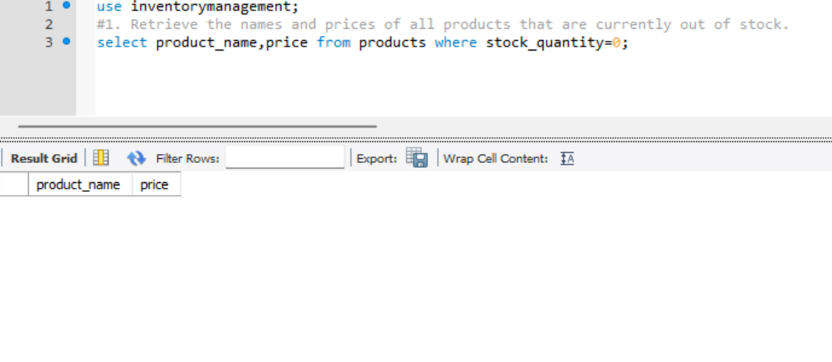

**Note:NO data is shown because there is no out of stock**

**List the total number of products in each category.**

**Query: select p.category_id,count(*),c.category_name from products as p join Categories as c on p.category_id=c.category_id group by category_id;**

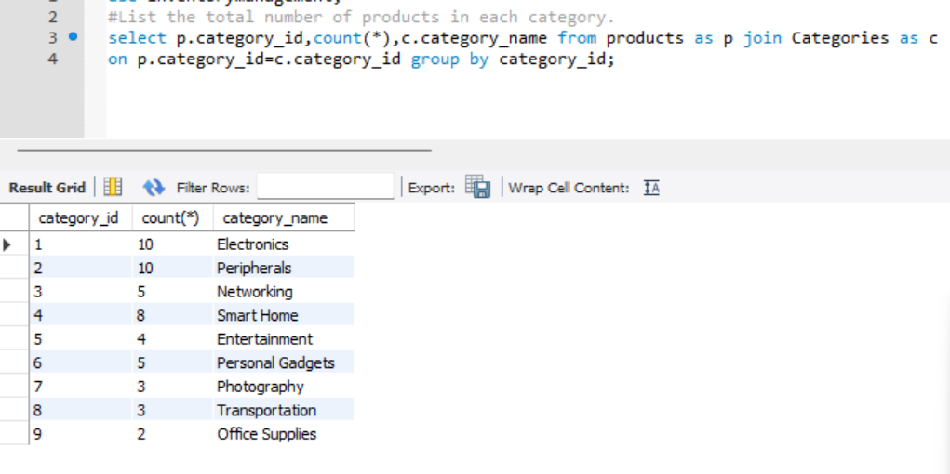

**Find all suppliers who have supplied products worth more than $10,000.**

**Query: select s.supplier_name,s.contact_name,o.total_amount from suppliers as sjoin orders as o on s.supplier_id=o.supplier_id where total_amount>10000;**

**Qurrie: select s.supplier_name,s.contact_name,o.total_amount from suppliers as sjoin orders as o on s.supplier_id=o.supplier_id where total_amount>10000;**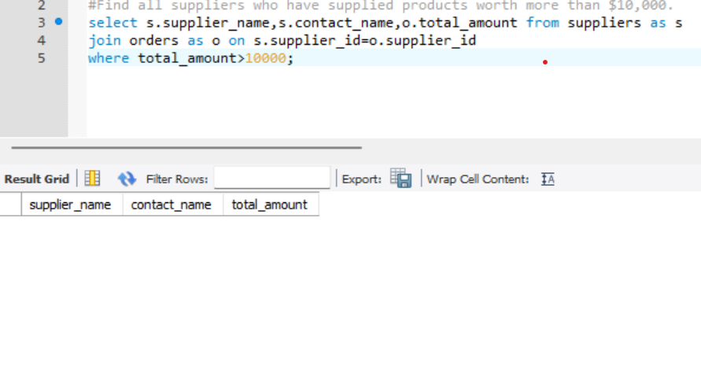

**Get the details of products with a stock quantity less than their reorder level.**

**Query: select product_name,stock_quantity,reorder_level from products**

**where stock_quantity<reorder_level;**

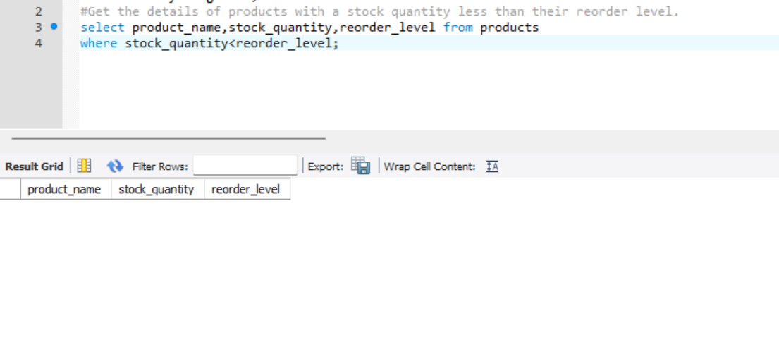

**NO data is fetched because there no storck_quantity Is less than reorder_level**

**Retrieve the order IDs and total amounts for orders placed in the last 30 days.**

**Query: select order_id,total_amount from orders**

**where order_date>=current_date()-interval 30 day;**

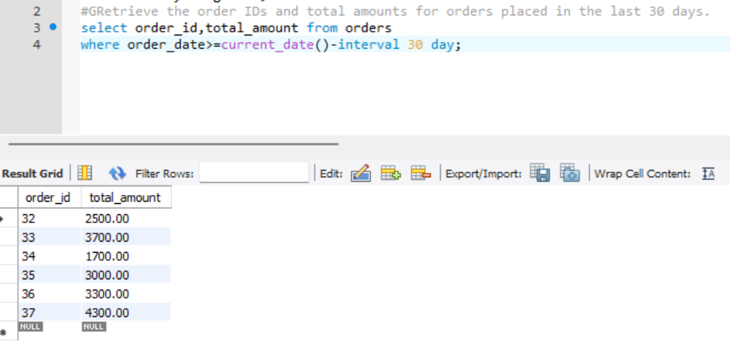

**List all products along with their categories, ordered by product name**

**Query: select p.category_id,p.product_name,c.category_name from products as pleft join categories as c on p.category_id=c.category_id order by product_name;**



**Get the names of suppliers who have not supplied any products in the last 6 months**

**Query: select s.supplier_name,s.contact_name from suppliers as s**

**join orders as o on s.supplier_id=o.supplier_id**

**where order_date is null>=current_date()- interval 6 month;**

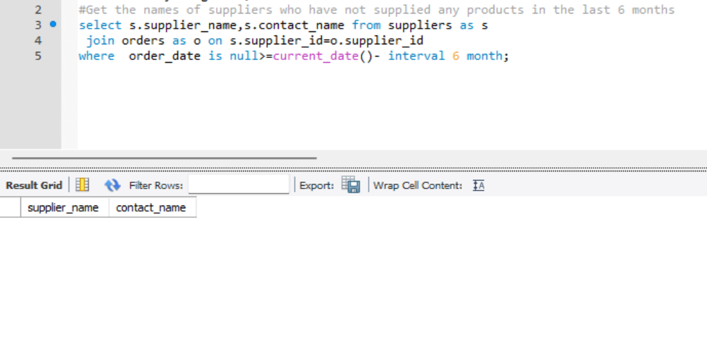

**Find the total amount spent on orders for each supplier.**

**Query: select s.supplier_name,s.contact_name,sum(o.total_amount) from suppliers as s**

**join orders as o on s.supplier_id=o.supplier_id**

**group by s.supplier_id order by contact_name;**

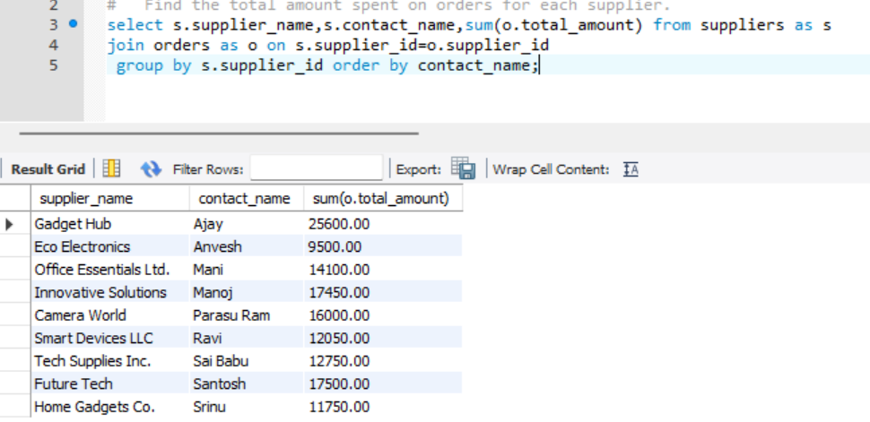

**Retrieve the product names and total quantities ordered for each product in the last year.**

**select p.product_name,sum(d.quantity) from products as p join Order_details as d on p.product_id=d.product_id**

**join orders as o on d.order_id=o.order_id where order_date>= current_date()- interval 1 year group by p.product_id;**

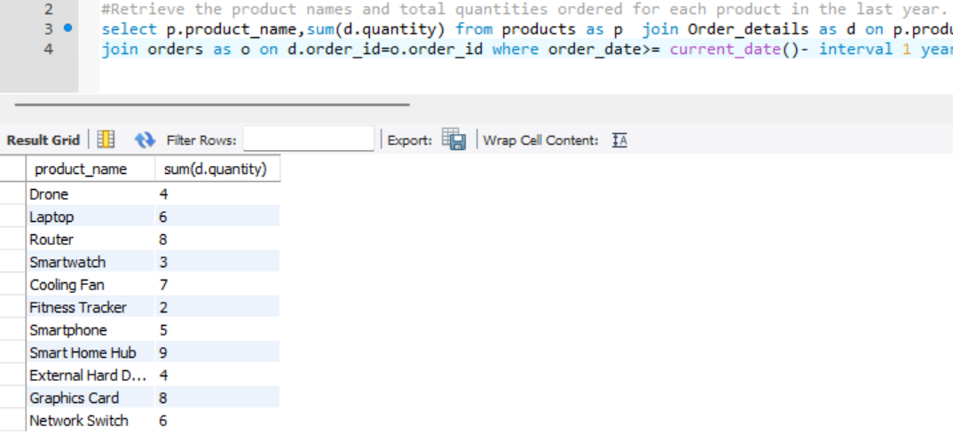

**Get a list of products that belong to the Electronics category and have a price greater than $500.**

**Query: select p.product_name,o.unit_price from products as p join order_details as o on p.product_id=o.product_id**

**join Categories as c on p.category_id=c.category_id where o.unit_price>500 and c.category_name='Electronics';**

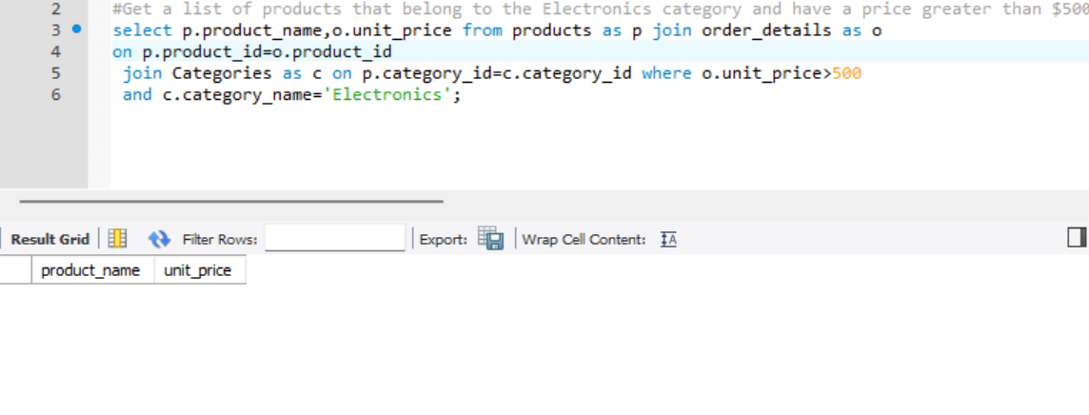

**Online Tutorial and Reference’s:**

• W3School HTML/CSS Tutorials, References and Examples @ http://www.w3schools.com/. (W3School is not related to W3C**)**